Data Visualization Final Project

Prof. Takacs

Student: Asuka Inoshita

**TOPIC: Shift of the World Population and Economic Power**

It’s been said that the world economy is set to shift as Asia becomes the largest trading region, fueling the rise of a mass affluent community and a new breed of corporations. According to United Nations’ research, just two countries, China and India, will account for 35% of the world’s population and 25% of global GDP. This megatrend looks at the global economic power shift. We will see a restructuring of the global economy with non-OECD economies expected to account for 57% of GDP by 2030. The economic influence of the G7 countries will shift to the Emerging 7 countries. By 2050 the E7 economies will be more than double that of the G7. I found this dataset from Kaggle.com, and it represents current(2020) data on the world population and various statistical attributes. I believe this data set is worthy to study to see if there are the signs of reflecting those predictions in several factors including current population, migrants, fertility rate, median age, and world share.

**A dataset: World Population by Country from Kaggle.com**

(<https://www.kaggle.com/datasets/muhammedtausif/world-population-by-countries>)

As the table shows, there are 11 variables (Country or dependency, Population 2020, Yearly Change, Net Change, Density, Land Area, Migrants, Fert Rate, Median Age, Urban Population, and World Share) for 235 countries

**Questions for analysis:**

1. What countries gain immigrants and what countries lose and what are the main factors? Political Situation (war, harsh dictatorship, religion, etc) Economical reasons?
2. Can we see this year’s fertility rate and the number of immigrants being the appropriate factors for economical growth prediction for the near future (2030, 2050)?
3. Does the median age of the country affect the future economical power and its shift in the ranking?

**Tableau Chart:** <https://public.tableau.com/app/profile/asuka.inoshita/viz/WorldPopulationShift/Population?publish=yes>

To respond to the analytical questions above, I’ve created a Tableau dashboard with three data visualization chart including a Map Chart, Box Chart, and Data Table.

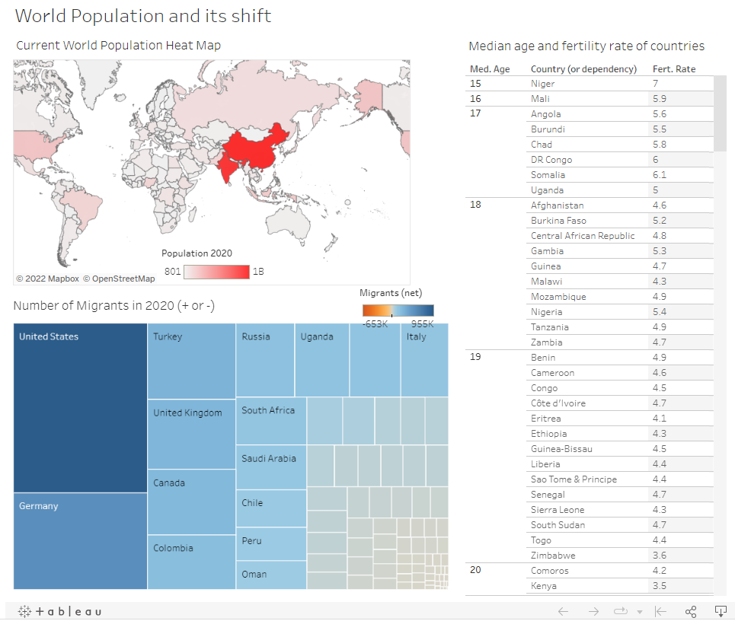

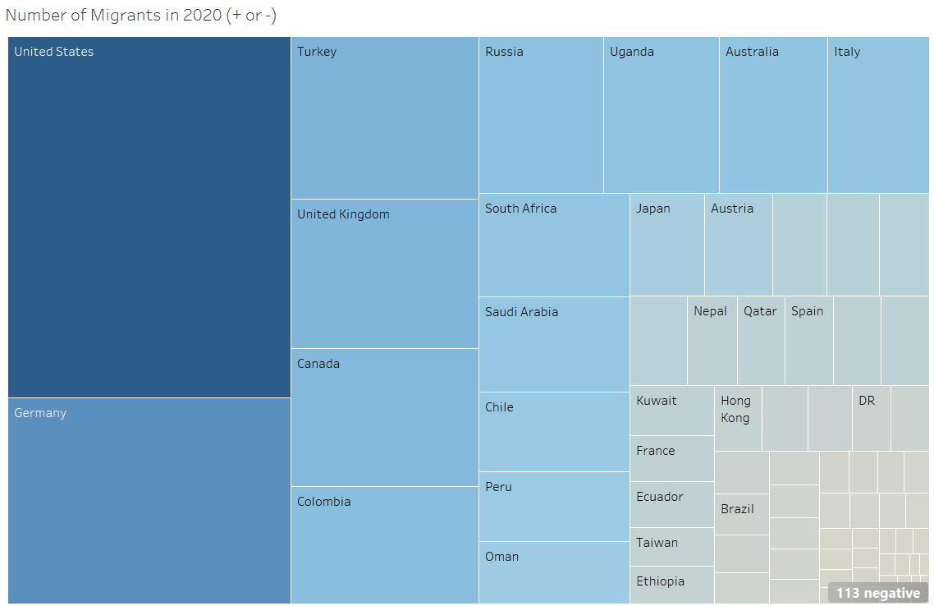

**Power ranking projections based on GDP (PPP) data chart (resource: World in 2050)**

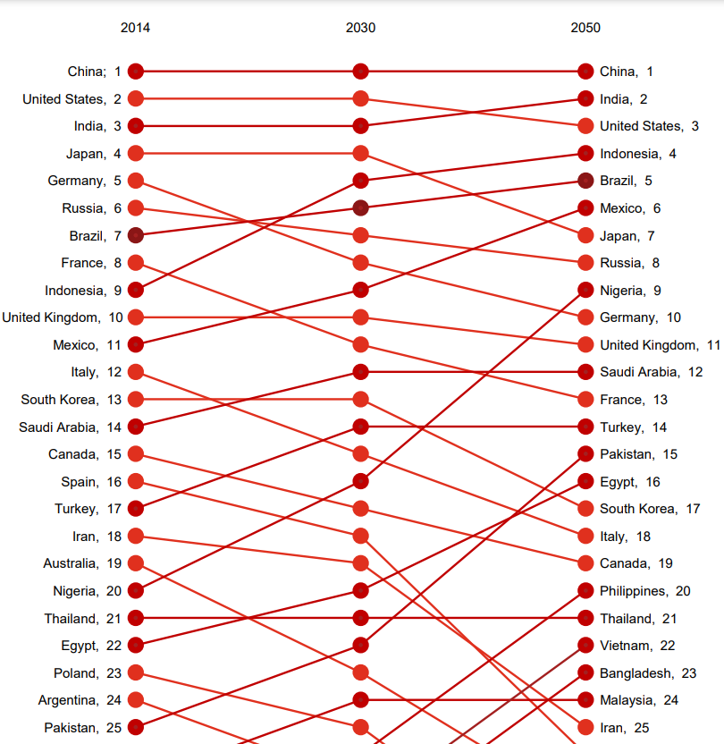

**The data tables below are created based on three data sources:**

Reference1- World Population Dataset (main source)

Reference2 - System of Governmnet by Countries (additional source)

Reference3 - World in 2050 (additional source)

[G7: Canada, France, Germany, Italy, Japan, the United Kingdom and the United States]

[E7: Brazil, China, India, Indonesia, Mexico, Russia, and Turkey]

Top 15 immigrants gaining countries in 2020:

| **Country(# of immigr of 2020)** | **Grouping** | **GDP Ranking in 2030** | **GDP Ranking in 2050** | **System of Government** | **Fertility Rate of 2020** | **Median Age** |
| --- | --- | --- | --- | --- | --- | --- |
| United States (954806) | G7 | 2 | 3 | Full Presidential Republics | 1.8 | 38 |
| Germany (543822) | G7 | 8 | 10 | Parliamentary republics | 1.6 | 46 |
| Turkey (283922) | E7 | 14 | 14 | Parliamentary republics | 2.1 | 32 |
| United Kingdom (260650) | G7 | 10 | 11 | Constitutional Monarchies with Celemonial Monarchs | 1.8 | 40 |
| Canada (242032) | G7 | 17 | 19 | Constitutional Monarchies with Celemonial Monarchs | 1.5 | 41 |
| Colombia (204796) | NaN | 30 | 29 | Full Presidential Republics | 1.8 | 31 |
| Russia (182456) | E7 | 7 | 8 | Presidential-Parliamentary system | 1.8 | 40 |
| Uganda (168694) | NaN | NaN | NaN | Full Presidential Republics | 5 | 17 |
| Australia (158246) | NaN | 23 | 28 | Constitutional Monarchies with Celemonial Monarchs | 1.8 | 38 |
| Italy (148943) | G7 | 15 | 18 | Parliamentary republics | 1.3 | 47 |
| South Africa (145405) | NaN | 31 | 27 | Presidential-republics w/ President and Prime Minister | 2.4 | 28 |
| Saudi Arabia (134979) | NaN | 12 | 12 | Absolute Monarchies | 2.3 | 32 |
| Chile (111708) | NaN | NaN | NaN | Full Presidential Republics | 1.7 | 35 |
| Peru (99069) | NaN | NaN | NaN | Full Presidential Republics | 2.3 | 31 |
| Oman (87400) | NaN | NaN | NaN | Presidential-Parliamentary system | 2.9 | 31 |

Worst 15 immigrants losing countries in 2020:

| **Country(# of immigr of 2020)** | **Grouping** | **GDP Ranking in 2030** | **GDP Ranking in 2050** | **System of Government** | **Fertility Rate of 2020** | **Median Age** |
| --- | --- | --- | --- | --- | --- | --- |
| Venezuela (-653249) | NaN | NaN | NaN | Full Presidential Republics | 2.8 | 26 |
| India (-532687) | E7 | 3 | 2 | Parliamentary republics | 2.1 | 28 |
| Syria (-427391) | NaN | NaN | NaN | Parliamentary republics | 1.7 | 38 |
| Bangladesh (-369501) | NaN | 29 | 23 | Parliamentary republics | 3.6 | 23 |
| China (-348399) | E7 | 1 | 1 | One-Party States | 1.7 | 19 |
| Pakistan (-233379) | NaN | 22 | 15 | Parliamentary republics | 2.2 | 29 |
| South Sudan (-174200) | NaN | NaN | NaN | Full Presidential Republics | 3.6 | 19 |
| Myanmar (-163313) | NaN | NaN | NaN | Military Dictatorship | 2.3 | 30 |
| Zimbabwe (-116858) | NaN | NaN | NaN | Presidential-Parliamentary system | 1.2 | 44 |
| Indonesia (-98955) | E7 | 5 | 4 | Full Presidential Republics | 2.2 | 34 |
| Puerto Rico (-97986) | NaN | NaN | NaN | Constitutional Monarchies with Celemonial Monarchs | 2.1 | 32 |
| Sri Lanka (-97986) | NaN | NaN | NaN | Presidential-Parliamentary system | 4.6 | 43 |
| Vietnam (-80000) | NaN | 28 | 22 | One-Party States | 2.6 | 26 |
| Romania (-73999) | NaN | NaN | NaN | Presidential-Parliamentary system | 1.6 | 18 |
| Philippines (-67152) | NaN | 26 | 20 | Full Presidential Republics | 2.1 | 29 |

**[The analysis to the questions]**

1. **What countries gain immigrants and what countries lose and what are the main factors? Political Situation (war, harsh dictatorship, religion, etc) Economical reasons?**

5 out of 7 G7 countries and 2 out of 7 E7 are listed in the top immigrants gainer list, and 3 of the E7 countries are listed in the largest immigrants loser list. Also, most of the top gainers are also the top GDP rankers in 2030 and 2050’s predictions. According to these results, current G7 countries are the top immigrants’ choices to move and those countries are predicted as the most wealthiest countries in the future. Though the political systems are so diverse, the population loser has some dictatorships and one-party states that don’t exist in the top gainer’s list. Therefore, I could conclude that both economical power and the political system are the incentive for the people’s decision making process in immigration. Just China and India’s case are controversial since they are listed both in E7 and top GDP producer lists but also in the largest population loser’s list. I could assume that it is because they are the largest populated countries, so that the number of outbound migration is simply larger than other nations because of their populational size difference.

1. **Can we see this year’s fertility rate and the number of immigrants being the appropriate factors for economical growth prediction for the near future (2030, 2050)?**

Most of the top population gainers and G7 countries have fertility rates lower than 2 which means their people are decreasing in numbers. However, due to the high number of in-bound immigrants, they could sustain and even gain growth in their population.

The largest population losers have a slightly higher fertility rate but don’t have clear evidence in this dataset. However, according to the National Library of Medicine, they mentions that Fertility rates tend to be higher in poorly resourced countries but due to high maternal and perinatal mortality, there is a reduction in birth rates. In developing countries, children are needed as a labour force and to provide care for their parents in old age. In these countries, fertility rates are higher due to the lack of access to contraceptives and generally lower levels of female education. The exceptional case is Uganda. It has a very high fertility rate (5) and also a high number of immigrants but is not listed in the current E7 list nor top GDP prediction lists. There is not enough data for Uganda to be proven as a highly growing nation in the dataset I have, however, we still could assume that this nation has the potential for future massive economic growth because GDP is strongly affected by population such as China, India, and the US prove.

1. **Does the median age of the country affect the future economical power and its shift in the ranking?**

Contrary to their birth rate, the average median age of top immigrants gainer nations seems slightly older than its counterpart. According to the National Library of Medicine, they mentions that he social structure, religious beliefs, economic prosperity and urbanisation within each country are likely to affect birth rates as well as abortion rates, Developed countries tend to have a lower fertility rate due to lifestyle choices associated with economic affluence where mortality rates are low, birth control is easily accessible and children often can become an economic drain caused by housing, education cost and other cost involved in bringing up children. However, despite their aging populations, most of the G7 nations remains highly ranked due to the inbounding immigrants who provide the economic workforce. On the other hand, despite the high number of outbounding immigrants, China, India, and Indonesia are rising their economical power and influence because of their stable birth rates from their existing high numbered young population. Therefore, I could conclude that the median age may affect the future economical power but not necessarily.

**Reference and resource**

The resources listed below are listed as the additional dataset or data source (world economical growth prediction data in GDP, world political and religious map, world education level map, world population growth prediction data, etc) for my final project. The Ref 1 is the base data that I utilize to develop the several questions to implement extensive research, and Ref 2-4 support to answer my assumptions.

Ref 1)<https://www.kaggle.com/datasets/muhammedtausif/world-population-by-countries>)

This dataset is **World Population by Country** from Kaggle.com. As the table shows, there are 11 variables (Country or dependency, Population 2020, Yearly Change, Net Change, Density, Land Area, Migrants, Fert Rate, Median Age, Urban Population, and World Share) for 235 countries. I utilized this dataset as the main reference data source to working on the world population predictions and to answer the assumption that listed in the body of this paper.

Ref 2)<https://www.pwc.com/gx/en/issues/the-economy/assets/world-in-2050-february-2015.pdf>

In this latest **World in 2050** report presenting economic growth projections for 32 of the largest economies in the world, accounting for around 84% of global GDP based on purchasing power parity (PPP) index. This dataset was helpful for me partially to answer my assumption “Is populational growth affects economic (ex. GDP) growth or does economical growth affect populational growth? Which is more appropriate?”, “Can we see this year’s fertility rate and the number of immigrants being the appropriate factors for economical growth prediction for the near future (2030, 2040, 2050)?”

Ref 3)<http://chartsbin.com/view/6kx>

**Systems of Government by Country**. This source shows the Systems of Government in the World. A systems of government or form of state governance, refers to the set of political institutions by which a government of a state is organized in order to exert its powers over a house in the congress body politic. This helped me to find the reasonable solution to the question “What countries gain immigrants and what countries lose and what are the main factors? Political Situation (war, harsh dictatorship, religion, etc) Economical reasons? “

Ref 4) <https://www.ncbi.nlm.nih.gov/pmc/articles/PMC4255510/#:~:text=The%20social%20structure%2C%20religious%20beliefs,rates%20are%20low%2C%20birth%20control>

# **Declining birth rate in Developed Countries.** Thisarticle is written by National Library of Medicine and the purpose of this information is to address raising awareness at an individual, family, community, and social level as well as at the primary, secondary, and tertiary healthcare level regarding factors affecting male and female fertility. This article is well explaining the reason why the developing and developed nation have gaps in fertility rate in the statistics and I found this source as a good additional resource to support my analysis especially for question 2 and 3.

[Full Original Data Source and Statistics]

| no | Country (or dependency) | Population 2020 | Yearly Change | Net Change | Density (P/Km²) | Land Area (Km²) | Migrants (net) | Fert. Rate | Med. Age | Urban Pop % | World Share |
| --- | --- | --- | --- | --- | --- | --- | --- | --- | --- | --- | --- |
| 1 | China | 1,439,323,776 | 0.39% | 5,540,090 | 153 | 9,388,211 | -348,399 | 1.7 | 38 | 61% | 18.47% |
| 2 | India | 1,380,004,385 | 0.99% | 13,586,631 | 464 | 2,973,190 | -532,687 | 2.2 | 28 | 35% | 17.70% |
| 3 | United States | 331,002,651 | 0.59% | 1,937,734 | 36 | 9,147,420 | 954,806 | 1.8 | 38 | 83% | 4.25% |
| 4 | Indonesia | 273,523,615 | 1.07% | 2,898,047 | 151 | 1,811,570 | -98,955 | 2.3 | 30 | 56% | 3.51% |
| 5 | Pakistan | 220,892,340 | 2.00% | 4,327,022 | 287 | 770,880 | -233,379 | 3.6 | 23 | 35% | 2.83% |
| 6 | Brazil | 212,559,417 | 0.72% | 1,509,890 | 25 | 8,358,140 | 21,200 | 1.7 | 33 | 88% | 2.73% |
| 7 | Nigeria | 206,139,589 | 2.58% | 5,175,990 | 226 | 910,770 | -60,000 | 5.4 | 18 | 52% | 2.64% |
| 8 | Bangladesh | 164,689,383 | 1.01% | 1,643,222 | 1,265 | 130,170 | -369,501 | 2.1 | 28 | 39% | 2.11% |
| 9 | Russia | 145,934,462 | 0.04% | 62,206 | 9 | 16,376,870 | 182,456 | 1.8 | 40 | 74% | 1.87% |
| 10 | Mexico | 128,932,753 | 1.06% | 1,357,224 | 66 | 1,943,950 | -60,000 | 2.1 | 29 | 84% | 1.65% |
| 11 | Japan | 126,476,461 | -0.30% | -383,840 | 347 | 364,555 | 71,560 | 1.4 | 48 | 92% | 1.62% |
| 12 | Ethiopia | 114,963,588 | 2.57% | 2,884,858 | 115 | 1,000,000 | 30,000 | 4.3 | 19 | 21% | 1.47% |
| 13 | Philippines | 109,581,078 | 1.35% | 1,464,463 | 368 | 298,170 | -67,152 | 2.6 | 26 | 47% | 1.41% |
| 14 | Egypt | 102,334,404 | 1.94% | 1,946,331 | 103 | 995,450 | -38,033 | 3.3 | 25 | 43% | 1.31% |
| 15 | Vietnam | 97,338,579 | 0.91% | 876,473 | 314 | 310,070 | -80,000 | 2.1 | 32 | 38% | 1.25% |
| 16 | DR Congo | 89,561,403 | 3.19% | 2,770,836 | 40 | 2,267,050 | 23,861 | 6 | 17 | 46% | 1.15% |
| 17 | Turkey | 84,339,067 | 1.09% | 909,452 | 110 | 769,630 | 283,922 | 2.1 | 32 | 76% | 1.08% |
| 18 | Iran | 83,992,949 | 1.30% | 1,079,043 | 52 | 1,628,550 | -55,000 | 2.2 | 32 | 76% | 1.08% |
| 19 | Germany | 83,783,942 | 0.32% | 266,897 | 240 | 348,560 | 543,822 | 1.6 | 46 | 76% | 1.07% |
| 20 | Thailand | 69,799,978 | 0.25% | 174,396 | 137 | 510,890 | 19,444 | 1.5 | 40 | 51% | 0.90% |
| 21 | United Kingdom | 67,886,011 | 0.53% | 355,839 | 281 | 241,930 | 260,650 | 1.8 | 40 | 83% | 0.87% |
| 22 | France | 65,273,511 | 0.22% | 143,783 | 119 | 547,557 | 36,527 | 1.9 | 42 | 82% | 0.84% |
| 23 | Italy | 60,461,826 | -0.15% | -88,249 | 206 | 294,140 | 148,943 | 1.3 | 47 | 69% | 0.78% |
| 24 | Tanzania | 59,734,218 | 2.98% | 1,728,755 | 67 | 885,800 | -40,076 | 4.9 | 18 | 37% | 0.77% |
| 25 | South Africa | 59,308,690 | 1.28% | 750,420 | 49 | 1,213,090 | 145,405 | 2.4 | 28 | 67% | 0.76% |
| 26 | Myanmar | 54,409,800 | 0.67% | 364,380 | 83 | 653,290 | -163,313 | 2.2 | 29 | 31% | 0.70% |
| 27 | Kenya | 53,771,296 | 2.28% | 1,197,323 | 94 | 569,140 | -10,000 | 3.5 | 20 | 28% | 0.69% |
| 28 | South Korea | 51,269,185 | 0.09% | 43,877 | 527 | 97,230 | 11,731 | 1.1 | 44 | 82% | 0.66% |
| 29 | Colombia | 50,882,891 | 1.08% | 543,448 | 46 | 1,109,500 | 204,796 | 1.8 | 31 | 80% | 0.65% |
| 30 | Spain | 46,754,778 | 0.04% | 18,002 | 94 | 498,800 | 40,000 | 1.3 | 45 | 80% | 0.60% |
| 31 | Uganda | 45,741,007 | 3.32% | 1,471,413 | 229 | 199,810 | 168,694 | 5 | 17 | 26% | 0.59% |
| 32 | Argentina | 45,195,774 | 0.93% | 415,097 | 17 | 2,736,690 | 4,800 | 2.3 | 32 | 93% | 0.58% |
| 33 | Algeria | 43,851,044 | 1.85% | 797,990 | 18 | 2,381,740 | -10,000 | 3.1 | 29 | 73% | 0.56% |
| 34 | Sudan | 43,849,260 | 2.42% | 1,036,022 | 25 | 1,765,048 | -50,000 | 4.4 | 20 | 35% | 0.56% |
| 35 | Ukraine | 43,733,762 | -0.59% | -259,876 | 75 | 579,320 | 10,000 | 1.4 | 41 | 69% | 0.56% |
| 36 | Iraq | 40,222,493 | 2.32% | 912,710 | 93 | 434,320 | 7,834 | 3.7 | 21 | 73% | 0.52% |
| 37 | Afghanistan | 38,928,346 | 2.33% | 886,592 | 60 | 652,860 | -62,920 | 4.6 | 18 | 25% | 0.50% |
| 38 | Poland | 37,846,611 | -0.11% | -41,157 | 124 | 306,230 | -29,395 | 1.4 | 42 | 60% | 0.49% |
| 39 | Canada | 37,742,154 | 0.89% | 331,107 | 4 | 9,093,510 | 242,032 | 1.5 | 41 | 81% | 0.48% |
| 40 | Morocco | 36,910,560 | 1.20% | 438,791 | 83 | 446,300 | -51,419 | 2.4 | 30 | 64% | 0.47% |
| 41 | Saudi Arabia | 34,813,871 | 1.59% | 545,343 | 16 | 2,149,690 | 134,979 | 2.3 | 32 | 84% | 0.45% |
| 42 | Uzbekistan | 33,469,203 | 1.48% | 487,487 | 79 | 425,400 | -8,863 | 2.4 | 28 | 50% | 0.43% |
| 43 | Peru | 32,971,854 | 1.42% | 461,401 | 26 | 1,280,000 | 99,069 | 2.3 | 31 | 79% | 0.42% |
| 44 | Angola | 32,866,272 | 3.27% | 1,040,977 | 26 | 1,246,700 | 6,413 | 5.6 | 17 | 67% | 0.42% |
| 45 | Malaysia | 32,365,999 | 1.30% | 416,222 | 99 | 328,550 | 50,000 | 2 | 30 | 78% | 0.42% |
| 46 | Mozambique | 31,255,435 | 2.93% | 889,399 | 40 | 786,380 | -5,000 | 4.9 | 18 | 38% | 0.40% |
| 47 | Ghana | 31,072,940 | 2.15% | 655,084 | 137 | 227,540 | -10,000 | 3.9 | 22 | 57% | 0.40% |
| 48 | Yemen | 29,825,964 | 2.28% | 664,042 | 56 | 527,970 | -30,000 | 3.8 | 20 | 38% | 0.38% |
| 49 | Nepal | 29,136,808 | 1.85% | 528,098 | 203 | 143,350 | 41,710 | 1.9 | 25 | 21% | 0.37% |
| 50 | Venezuela | 28,435,940 | -0.28% | -79,889 | 32 | 882,050 | -653,249 | 2.3 | 30 | N.A. | 0.36% |
| 51 | Madagascar | 27,691,018 | 2.68% | 721,711 | 48 | 581,795 | -1,500 | 4.1 | 20 | 39% | 0.36% |
| 52 | Cameroon | 26,545,863 | 2.59% | 669,483 | 56 | 472,710 | -4,800 | 4.6 | 19 | 56% | 0.34% |
| 53 | Côte d'Ivoire | 26,378,274 | 2.57% | 661,730 | 83 | 318,000 | -8,000 | 4.7 | 19 | 51% | 0.34% |
| 54 | North Korea | 25,778,816 | 0.44% | 112,655 | 214 | 120,410 | -5,403 | 1.9 | 35 | 63% | 0.33% |
| 55 | Australia | 25,499,884 | 1.18% | 296,686 | 3 | 7,682,300 | 158,246 | 1.8 | 38 | 86% | 0.33% |
| 56 | Niger | 24,206,644 | 3.84% | 895,929 | 19 | 1,266,700 | 4,000 | 7 | 15 | 17% | 0.31% |
| 57 | Taiwan | 23,816,775 | 0.18% | 42,899 | 673 | 35,410 | 30,001 | 1.2 | 42 | 79% | 0.31% |
| 58 | Sri Lanka | 21,413,249 | 0.42% | 89,516 | 341 | 62,710 | -97,986 | 2.2 | 34 | 18% | 0.27% |
| 59 | Burkina Faso | 20,903,273 | 2.86% | 581,895 | 76 | 273,600 | -25,000 | 5.2 | 18 | 31% | 0.27% |
| 60 | Mali | 20,250,833 | 3.02% | 592,802 | 17 | 1,220,190 | -40,000 | 5.9 | 16 | 44% | 0.26% |
| 61 | Romania | 19,237,691 | -0.66% | -126,866 | 84 | 230,170 | -73,999 | 1.6 | 43 | 55% | 0.25% |
| 62 | Malawi | 19,129,952 | 2.69% | 501,205 | 203 | 94,280 | -16,053 | 4.3 | 18 | 18% | 0.25% |
| 63 | Chile | 19,116,201 | 0.87% | 164,163 | 26 | 743,532 | 111,708 | 1.7 | 35 | 85% | 0.25% |
| 64 | Kazakhstan | 18,776,707 | 1.21% | 225,280 | 7 | 2,699,700 | -18,000 | 2.8 | 31 | 58% | 0.24% |
| 65 | Zambia | 18,383,955 | 2.93% | 522,925 | 25 | 743,390 | -8,000 | 4.7 | 18 | 45% | 0.24% |
| 66 | Guatemala | 17,915,568 | 1.90% | 334,096 | 167 | 107,160 | -9,215 | 2.9 | 23 | 52% | 0.23% |
| 67 | Ecuador | 17,643,054 | 1.55% | 269,392 | 71 | 248,360 | 36,400 | 2.4 | 28 | 63% | 0.23% |
| 68 | Syria | 17,500,658 | 2.52% | 430,523 | 95 | 183,630 | -427,391 | 2.8 | 26 | 60% | 0.22% |
| 69 | Netherlands | 17,134,872 | 0.22% | 37,742 | 508 | 33,720 | 16,000 | 1.7 | 43 | 92% | 0.22% |
| 70 | Senegal | 16,743,927 | 2.75% | 447,563 | 87 | 192,530 | -20,000 | 4.7 | 19 | 49% | 0.21% |
| 71 | Cambodia | 16,718,965 | 1.41% | 232,423 | 95 | 176,520 | -30,000 | 2.5 | 26 | 24% | 0.21% |
| 72 | Chad | 16,425,864 | 3.00% | 478,988 | 13 | 1,259,200 | 2,000 | 5.8 | 17 | 23% | 0.21% |
| 73 | Somalia | 15,893,222 | 2.92% | 450,317 | 25 | 627,340 | -40,000 | 6.1 | 17 | 47% | 0.20% |
| 74 | Zimbabwe | 14,862,924 | 1.48% | 217,456 | 38 | 386,850 | -116,858 | 3.6 | 19 | 38% | 0.19% |
| 75 | Guinea | 13,132,795 | 2.83% | 361,549 | 53 | 245,720 | -4,000 | 4.7 | 18 | 39% | 0.17% |
| 76 | Rwanda | 12,952,218 | 2.58% | 325,268 | 525 | 24,670 | -9,000 | 4.1 | 20 | 18% | 0.17% |
| 77 | Benin | 12,123,200 | 2.73% | 322,049 | 108 | 112,760 | -2,000 | 4.9 | 19 | 48% | 0.16% |
| 78 | Burundi | 11,890,784 | 3.12% | 360,204 | 463 | 25,680 | 2,001 | 5.5 | 17 | 14% | 0.15% |
| 79 | Tunisia | 11,818,619 | 1.06% | 123,900 | 76 | 155,360 | -4,000 | 2.2 | 33 | 70% | 0.15% |
| 80 | Bolivia | 11,673,021 | 1.39% | 159,921 | 11 | 1,083,300 | -9,504 | 2.8 | 26 | 69% | 0.15% |
| 81 | Belgium | 11,589,623 | 0.44% | 50,295 | 383 | 30,280 | 48,000 | 1.7 | 42 | 98% | 0.15% |
| 82 | Haiti | 11,402,528 | 1.24% | 139,451 | 414 | 27,560 | -35,000 | 3 | 24 | 57% | 0.15% |
| 83 | Cuba | 11,326,616 | -0.06% | -6,867 | 106 | 106,440 | -14,400 | 1.6 | 42 | 78% | 0.15% |
| 84 | South Sudan | 11,193,725 | 1.19% | 131,612 | 18 | 610,952 | -174,200 | 4.7 | 19 | 25% | 0.14% |
| 85 | Dominican Republic | 10,847,910 | 1.01% | 108,952 | 225 | 48,320 | -30,000 | 2.4 | 28 | 85% | 0.14% |
| 86 | Czech Republic (Czechia) | 10,708,981 | 0.18% | 19,772 | 139 | 77,240 | 22,011 | 1.6 | 43 | 74% | 0.14% |
| 87 | Greece | 10,423,054 | -0.48% | -50,401 | 81 | 128,900 | -16,000 | 1.3 | 46 | 85% | 0.13% |
| 88 | Jordan | 10,203,134 | 1.00% | 101,440 | 115 | 88,780 | 10,220 | 2.8 | 24 | 91% | 0.13% |
| 89 | Portugal | 10,196,709 | -0.29% | -29,478 | 111 | 91,590 | -6,000 | 1.3 | 46 | 66% | 0.13% |
| 90 | Azerbaijan | 10,139,177 | 0.91% | 91,459 | 123 | 82,658 | 1,200 | 2.1 | 32 | 56% | 0.13% |
| 91 | Sweden | 10,099,265 | 0.63% | 62,886 | 25 | 410,340 | 40,000 | 1.9 | 41 | 88% | 0.13% |
| 92 | Honduras | 9,904,607 | 1.63% | 158,490 | 89 | 111,890 | -6,800 | 2.5 | 24 | 57% | 0.13% |
| 93 | United Arab Emirates | 9,890,402 | 1.23% | 119,873 | 118 | 83,600 | 40,000 | 1.4 | 33 | 86% | 0.13% |
| 94 | Hungary | 9,660,351 | -0.25% | -24,328 | 107 | 90,530 | 6,000 | 1.5 | 43 | 72% | 0.12% |
| 95 | Tajikistan | 9,537,645 | 2.32% | 216,627 | 68 | 139,960 | -20,000 | 3.6 | 22 | 27% | 0.12% |
| 96 | Belarus | 9,449,323 | -0.03% | -3,088 | 47 | 202,910 | 8,730 | 1.7 | 40 | 79% | 0.12% |
| 97 | Austria | 9,006,398 | 0.57% | 51,296 | 109 | 82,409 | 65,000 | 1.5 | 43 | 57% | 0.12% |
| 98 | Papua New Guinea | 8,947,024 | 1.95% | 170,915 | 20 | 452,860 | -800 | 3.6 | 22 | 13% | 0.11% |
| 99 | Serbia | 8,737,371 | -0.40% | -34,864 | 100 | 87,460 | 4,000 | 1.5 | 42 | 56% | 0.11% |
| 100 | Israel | 8,655,535 | 1.60% | 136,158 | 400 | 21,640 | 10,000 | 3 | 30 | 93% | 0.11% |
| 101 | Switzerland | 8,654,622 | 0.74% | 63,257 | 219 | 39,516 | 52,000 | 1.5 | 43 | 74% | 0.11% |
| 102 | Togo | 8,278,724 | 2.43% | 196,358 | 152 | 54,390 | -2,000 | 4.4 | 19 | 43% | 0.11% |
| 103 | Sierra Leone | 7,976,983 | 2.10% | 163,768 | 111 | 72,180 | -4,200 | 4.3 | 19 | 43% | 0.10% |
| 104 | Hong Kong | 7,496,981 | 0.82% | 60,827 | 7,140 | 1,050 | 29,308 | 1.3 | 45 | N.A. | 0.10% |
| 105 | Laos | 7,275,560 | 1.48% | 106,105 | 32 | 230,800 | -14,704 | 2.7 | 24 | 36% | 0.09% |
| 106 | Paraguay | 7,132,538 | 1.25% | 87,902 | 18 | 397,300 | -16,556 | 2.4 | 26 | 62% | 0.09% |
| 107 | Bulgaria | 6,948,445 | -0.74% | -51,674 | 64 | 108,560 | -4,800 | 1.6 | 45 | 76% | 0.09% |
| 108 | Libya | 6,871,292 | 1.38% | 93,840 | 4 | 1,759,540 | -1,999 | 2.3 | 29 | 78% | 0.09% |
| 109 | Lebanon | 6,825,445 | -0.44% | -30,268 | 667 | 10,230 | -30,012 | 2.1 | 30 | 78% | 0.09% |
| 110 | Nicaragua | 6,624,554 | 1.21% | 79,052 | 55 | 120,340 | -21,272 | 2.4 | 26 | 57% | 0.08% |
| 111 | Kyrgyzstan | 6,524,195 | 1.69% | 108,345 | 34 | 191,800 | -4,000 | 3 | 26 | 36% | 0.08% |
| 112 | El Salvador | 6,486,205 | 0.51% | 32,652 | 313 | 20,720 | -40,539 | 2.1 | 28 | 73% | 0.08% |
| 113 | Turkmenistan | 6,031,200 | 1.50% | 89,111 | 13 | 469,930 | -5,000 | 2.8 | 27 | 53% | 0.08% |
| 114 | Singapore | 5,850,342 | 0.79% | 46,005 | 8,358 | 700 | 27,028 | 1.2 | 42 | N.A. | 0.08% |
| 115 | Denmark | 5,792,202 | 0.35% | 20,326 | 137 | 42,430 | 15,200 | 1.8 | 42 | 88% | 0.07% |
| 116 | Finland | 5,540,720 | 0.15% | 8,564 | 18 | 303,890 | 14,000 | 1.5 | 43 | 86% | 0.07% |
| 117 | Congo | 5,518,087 | 2.56% | 137,579 | 16 | 341,500 | -4,000 | 4.5 | 19 | 70% | 0.07% |
| 118 | Slovakia | 5,459,642 | 0.05% | 2,629 | 114 | 48,088 | 1,485 | 1.5 | 41 | 54% | 0.07% |
| 119 | Norway | 5,421,241 | 0.79% | 42,384 | 15 | 365,268 | 28,000 | 1.7 | 40 | 83% | 0.07% |
| 120 | Oman | 5,106,626 | 2.65% | 131,640 | 16 | 309,500 | 87,400 | 2.9 | 31 | 87% | 0.07% |
| 121 | State of Palestine | 5,101,414 | 2.41% | 119,994 | 847 | 6,020 | -10,563 | 3.7 | 21 | 80% | 0.07% |
| 122 | Costa Rica | 5,094,118 | 0.92% | 46,557 | 100 | 51,060 | 4,200 | 1.8 | 33 | 80% | 0.07% |
| 123 | Liberia | 5,057,681 | 2.44% | 120,307 | 53 | 96,320 | -5,000 | 4.4 | 19 | 53% | 0.06% |
| 124 | Ireland | 4,937,786 | 1.13% | 55,291 | 72 | 68,890 | 23,604 | 1.8 | 38 | 63% | 0.06% |
| 125 | Central African Republic | 4,829,767 | 1.78% | 84,582 | 8 | 622,980 | -40,000 | 4.8 | 18 | 43% | 0.06% |
| 126 | New Zealand | 4,822,233 | 0.82% | 39,170 | 18 | 263,310 | 14,881 | 1.9 | 38 | 87% | 0.06% |
| 127 | Mauritania | 4,649,658 | 2.74% | 123,962 | 5 | 1,030,700 | 5,000 | 4.6 | 20 | 57% | 0.06% |
| 128 | Panama | 4,314,767 | 1.61% | 68,328 | 58 | 74,340 | 11,200 | 2.5 | 30 | 68% | 0.06% |
| 129 | Kuwait | 4,270,571 | 1.51% | 63,488 | 240 | 17,820 | 39,520 | 2.1 | 37 | N.A. | 0.05% |
| 130 | Croatia | 4,105,267 | -0.61% | -25,037 | 73 | 55,960 | -8,001 | 1.4 | 44 | 58% | 0.05% |
| 131 | Moldova | 4,033,963 | -0.23% | -9,300 | 123 | 32,850 | -1,387 | 1.3 | 38 | 43% | 0.05% |
| 132 | Georgia | 3,989,167 | -0.19% | -7,598 | 57 | 69,490 | -10,000 | 2.1 | 38 | 58% | 0.05% |
| 133 | Eritrea | 3,546,421 | 1.41% | 49,304 | 35 | 101,000 | -39,858 | 4.1 | 19 | 63% | 0.05% |
| 134 | Uruguay | 3,473,730 | 0.35% | 11,996 | 20 | 175,020 | -3,000 | 2 | 36 | 96% | 0.04% |
| 135 | Bosnia and Herzegovina | 3,280,819 | -0.61% | -20,181 | 64 | 51,000 | -21,585 | 1.3 | 43 | 52% | 0.04% |
| 136 | Mongolia | 3,278,290 | 1.65% | 53,123 | 2 | 1,553,560 | -852 | 2.9 | 28 | 67% | 0.04% |
| 137 | Armenia | 2,963,243 | 0.19% | 5,512 | 104 | 28,470 | -4,998 | 1.8 | 35 | 63% | 0.04% |
| 138 | Jamaica | 2,961,167 | 0.44% | 12,888 | 273 | 10,830 | -11,332 | 2 | 31 | 55% | 0.04% |
| 139 | Qatar | 2,881,053 | 1.73% | 48,986 | 248 | 11,610 | 40,000 | 1.9 | 32 | 96% | 0.04% |
| 140 | Albania | 2,877,797 | -0.11% | -3,120 | 105 | 27,400 | -14,000 | 1.6 | 36 | 63% | 0.04% |
| 141 | Puerto Rico | 2,860,853 | -2.47% | -72,555 | 323 | 8,870 | -97,986 | 1.2 | 44 | N.A. | 0.04% |
| 142 | Lithuania | 2,722,289 | -1.35% | -37,338 | 43 | 62,674 | -32,780 | 1.7 | 45 | 71% | 0.03% |
| 143 | Namibia | 2,540,905 | 1.86% | 46,375 | 3 | 823,290 | -4,806 | 3.4 | 22 | 55% | 0.03% |
| 144 | Gambia | 2,416,668 | 2.94% | 68,962 | 239 | 10,120 | -3,087 | 5.3 | 18 | 59% | 0.03% |
| 145 | Botswana | 2,351,627 | 2.08% | 47,930 | 4 | 566,730 | 3,000 | 2.9 | 24 | 73% | 0.03% |
| 146 | Gabon | 2,225,734 | 2.45% | 53,155 | 9 | 257,670 | 3,260 | 4 | 23 | 87% | 0.03% |
| 147 | Lesotho | 2,142,249 | 0.80% | 16,981 | 71 | 30,360 | -10,047 | 3.2 | 24 | 31% | 0.03% |
| 148 | North Macedonia | 2,083,374 | 0.00% | -85 | 83 | 25,220 | -1,000 | 1.5 | 39 | 59% | 0.03% |
| 149 | Slovenia | 2,078,938 | 0.01% | 284 | 103 | 20,140 | 2,000 | 1.6 | 45 | 55% | 0.03% |
| 150 | Guinea-Bissau | 1,968,001 | 2.45% | 47,079 | 70 | 28,120 | -1,399 | 4.5 | 19 | 45% | 0.03% |
| 151 | Latvia | 1,886,198 | -1.08% | -20,545 | 30 | 62,200 | -14,837 | 1.7 | 44 | 69% | 0.02% |
| 152 | Bahrain | 1,701,575 | 3.68% | 60,403 | 2,239 | 760 | 47,800 | 2 | 32 | 89% | 0.02% |
| 153 | Equatorial Guinea | 1,402,985 | 3.47% | 46,999 | 50 | 28,050 | 16,000 | 4.6 | 22 | 73% | 0.02% |
| 154 | Trinidad and Tobago | 1,399,488 | 0.32% | 4,515 | 273 | 5,130 | -800 | 1.7 | 36 | 52% | 0.02% |
| 155 | Estonia | 1,326,535 | 0.07% | 887 | 31 | 42,390 | 3,911 | 1.6 | 42 | 68% | 0.02% |
| 156 | Timor-Leste | 1,318,445 | 1.96% | 25,326 | 89 | 14,870 | -5,385 | 4.1 | 21 | 33% | 0.02% |
| 157 | Mauritius | 1,271,768 | 0.17% | 2,100 | 626 | 2,030 | 0 | 1.4 | 37 | 41% | 0.02% |
| 158 | Cyprus | 1,207,359 | 0.73% | 8,784 | 131 | 9,240 | 5,000 | 1.3 | 37 | 67% | 0.02% |
| 159 | Eswatini | 1,160,164 | 1.05% | 12,034 | 67 | 17,200 | -8,353 | 3 | 21 | 30% | 0.01% |
| 160 | Djibouti | 988,000 | 1.48% | 14,440 | 43 | 23,180 | 900 | 2.8 | 27 | 79% | 0.01% |
| 161 | Fiji | 896,445 | 0.73% | 6,492 | 49 | 18,270 | -6,202 | 2.8 | 28 | 59% | 0.01% |
| 162 | Réunion | 895,312 | 0.72% | 6,385 | 358 | 2,500 | -1,256 | 2.3 | 36 | 100% | 0.01% |
| 163 | Comoros | 869,601 | 2.20% | 18,715 | 467 | 1,861 | -2,000 | 4.2 | 20 | 29% | 0.01% |
| 164 | Guyana | 786,552 | 0.48% | 3,786 | 4 | 196,850 | -6,000 | 2.5 | 27 | 27% | 0.01% |
| 165 | Bhutan | 771,608 | 1.12% | 8,516 | 20 | 38,117 | 320 | 2 | 28 | 46% | 0.01% |
| 166 | Solomon Islands | 686,884 | 2.55% | 17,061 | 25 | 27,990 | -1,600 | 4.4 | 20 | 23% | 0.01% |
| 167 | Macao | 649,335 | 1.39% | 8,890 | 21,645 | 30 | 5,000 | 1.2 | 39 | N.A. | 0.01% |
| 168 | Montenegro | 628,066 | 0.01% | 79 | 47 | 13,450 | -480 | 1.8 | 39 | 68% | 0.01% |
| 169 | Luxembourg | 625,978 | 1.66% | 10,249 | 242 | 2,590 | 9,741 | 1.5 | 40 | 88% | 0.01% |
| 170 | Western Sahara | 597,339 | 2.55% | 14,876 | 2 | 266,000 | 5,582 | 2.4 | 28 | 87% | 0.01% |
| 171 | Suriname | 586,632 | 0.90% | 5,260 | 4 | 156,000 | -1,000 | 2.4 | 29 | 65% | 0.01% |
| 172 | Cabo Verde | 555,987 | 1.10% | 6,052 | 138 | 4,030 | -1,342 | 2.3 | 28 | 68% | 0.01% |
| 173 | Micronesia | 548,914 | 1.00% | 5,428 | 784 | 700 | -2,957 | 2.9 | 27 | 68% | 0.01% |
| 174 | Maldives | 540,544 | 1.81% | 9,591 | 1,802 | 300 | 11,370 | 1.9 | 30 | 35% | 0.01% |
| 175 | Malta | 441,543 | 0.27% | 1,171 | 1,380 | 320 | 900 | 1.5 | 43 | 93% | 0.01% |
| 176 | Brunei | 437,479 | 0.97% | 4,194 | 83 | 5,270 | 0 | 1.8 | 32 | 80% | 0.01% |
| 177 | Guadeloupe | 400,124 | 0.02% | 68 | 237 | 1,690 | -1,440 | 2.2 | 44 | N.A. | 0.01% |
| 178 | Belize | 397,628 | 1.86% | 7,275 | 17 | 22,810 | 1,200 | 2.3 | 25 | 46% | 0.01% |
| 179 | Bahamas | 393,244 | 0.97% | 3,762 | 39 | 10,010 | 1,000 | 1.8 | 32 | 86% | 0.01% |
| 180 | Martinique | 375,265 | -0.08% | -289 | 354 | 1,060 | -960 | 1.9 | 47 | 92% | 0.00% |
| 181 | Iceland | 341,243 | 0.65% | 2,212 | 3 | 100,250 | 380 | 1.8 | 37 | 94% | 0.00% |
| 182 | Vanuatu | 307,145 | 2.42% | 7,263 | 25 | 12,190 | 120 | 3.8 | 21 | 24% | 0.00% |
| 183 | French Guiana | 298,682 | 2.70% | 7,850 | 4 | 82,200 | 1,200 | 3.4 | 25 | 87% | 0.00% |
| 184 | Barbados | 287,375 | 0.12% | 350 | 668 | 430 | -79 | 1.6 | 40 | 31% | 0.00% |
| 185 | New Caledonia | 285,498 | 0.97% | 2,748 | 16 | 18,280 | 502 | 2 | 34 | 72% | 0.00% |
| 186 | French Polynesia | 280,908 | 0.58% | 1,621 | 77 | 3,660 | -1,000 | 2 | 34 | 64% | 0.00% |
| 187 | Mayotte | 272,815 | 2.50% | 6,665 | 728 | 375 | 0 | 3.7 | 20 | 46% | 0.00% |
| 188 | Sao Tome & Principe | 219,159 | 1.91% | 4,103 | 228 | 960 | -1,680 | 4.4 | 19 | 74% | 0.00% |
| 189 | Samoa | 198,414 | 0.67% | 1,317 | 70 | 2,830 | -2,803 | 3.9 | 22 | 18% | 0.00% |
| 190 | Saint Lucia | 183,627 | 0.46% | 837 | 301 | 610 | 0 | 1.4 | 34 | 19% | 0.00% |
| 191 | Channel Islands | 173,863 | 0.93% | 1,604 | 915 | 190 | 1,351 | 1.5 | 43 | 30% | 0.00% |
| 192 | Guam | 168,775 | 0.89% | 1,481 | 313 | 540 | -506 | 2.3 | 31 | 95% | 0.00% |
| 193 | Curaçao | 164,093 | 0.41% | 669 | 370 | 444 | 515 | 1.8 | 42 | 89% | 0.00% |
| 194 | Kiribati | 119,449 | 1.57% | 1,843 | 147 | 810 | -800 | 3.6 | 23 | 57% | 0.00% |
| 195 | Grenada | 112,523 | 0.46% | 520 | 331 | 340 | -200 | 2.1 | 32 | 35% | 0.00% |
| 196 | St. Vincent & Grenadines | 110,940 | 0.32% | 351 | 284 | 390 | -200 | 1.9 | 33 | 53% | 0.00% |
| 197 | Aruba | 106,766 | 0.43% | 452 | 593 | 180 | 201 | 1.9 | 41 | 44% | 0.00% |
| 198 | Tonga | 105,695 | 1.15% | 1,201 | 147 | 720 | -800 | 3.6 | 22 | 24% | 0.00% |
| 199 | U.S. Virgin Islands | 104,425 | -0.15% | -153 | 298 | 350 | -451 | 2 | 43 | 96% | 0.00% |
| 200 | Seychelles | 98,347 | 0.62% | 608 | 214 | 460 | -200 | 2.5 | 34 | 56% | 0.00% |
| 201 | Antigua and Barbuda | 97,929 | 0.84% | 811 | 223 | 440 | 0 | 2 | 34 | 26% | 0.00% |
| 202 | Isle of Man | 85,033 | 0.53% | 449 | 149 | 570 |  | N.A. | N.A. | 53% | 0.00% |
| 203 | Andorra | 77,265 | 0.16% | 123 | 164 | 470 |  | N.A. | N.A. | 88% | 0.00% |
| 204 | Dominica | 71,986 | 0.25% | 178 | 96 | 750 |  | N.A. | N.A. | 74% | 0.00% |
| 205 | Cayman Islands | 65,722 | 1.19% | 774 | 274 | 240 |  | N.A. | N.A. | 97% | 0.00% |
| 206 | Bermuda | 62,278 | -0.36% | -228 | 1,246 | 50 |  | N.A. | N.A. | 97% | 0.00% |
| 207 | Marshall Islands | 59,190 | 0.68% | 399 | 329 | 180 |  | N.A. | N.A. | 70% | 0.00% |
| 208 | Northern Mariana Islands | 57,559 | 0.60% | 343 | 125 | 460 |  | N.A. | N.A. | 88% | 0.00% |
| 209 | Greenland | 56,770 | 0.17% | 98 | 0 | 410,450 |  | N.A. | N.A. | 87% | 0.00% |
| 210 | American Samoa | 55,191 | -0.22% | -121 | 276 | 200 |  | N.A. | N.A. | 88% | 0.00% |
| 211 | Saint Kitts & Nevis | 53,199 | 0.71% | 376 | 205 | 260 |  | N.A. | N.A. | 33% | 0.00% |
| 212 | Faeroe Islands | 48,863 | 0.38% | 185 | 35 | 1,396 |  | N.A. | N.A. | 43% | 0.00% |
| 213 | Sint Maarten | 42,876 | 1.15% | 488 | 1,261 | 34 |  | N.A. | N.A. | 96% | 0.00% |
| 214 | Monaco | 39,242 | 0.71% | 278 | 26,337 | 1 |  | N.A. | N.A. | N.A. | 0.00% |
| 215 | Turks and Caicos | 38,717 | 1.38% | 526 | 41 | 950 |  | N.A. | N.A. | 89% | 0.00% |
| 216 | Saint Martin | 38,666 | 1.75% | 664 | 730 | 53 |  | N.A. | N.A. | 0% | 0.00% |
| 217 | Liechtenstein | 38,128 | 0.29% | 109 | 238 | 160 |  | N.A. | N.A. | 15% | 0.00% |
| 218 | San Marino | 33,931 | 0.21% | 71 | 566 | 60 |  | N.A. | N.A. | 97% | 0.00% |
| 219 | Gibraltar | 33,691 | -0.03% | -10 | 3,369 | 10 |  | N.A. | N.A. | N.A. | 0.00% |
| 220 | British Virgin Islands | 30,231 | 0.67% | 201 | 202 | 150 |  | N.A. | N.A. | 52% | 0.00% |
| 221 | Caribbean Netherlands | 26,223 | 0.94% | 244 | 80 | 328 |  | N.A. | N.A. | 75% | 0.00% |
| 222 | Palau | 18,094 | 0.48% | 86 | 39 | 460 |  | N.A. | N.A. | N.A. | 0.00% |
| 223 | Cook Islands | 17,564 | 0.09% | 16 | 73 | 240 |  | N.A. | N.A. | 75% | 0.00% |
| 224 | Anguilla | 15,003 | 0.90% | 134 | 167 | 90 |  | N.A. | N.A. | N.A. | 0.00% |
| 225 | Tuvalu | 11,792 | 1.25% | 146 | 393 | 30 |  | N.A. | N.A. | 62% | 0.00% |
| 226 | Wallis & Futuna | 11,239 | -1.69% | -193 | 80 | 140 |  | N.A. | N.A. | 0% | 0.00% |
| 227 | Nauru | 10,824 | 0.63% | 68 | 541 | 20 |  | N.A. | N.A. | N.A. | 0.00% |
| 228 | Saint Barthelemy | 9,877 | 0.30% | 30 | 470 | 21 |  | N.A. | N.A. | 0% | 0.00% |
| 229 | Saint Helena | 6,077 | 0.30% | 18 | 16 | 390 |  | N.A. | N.A. | 27% | 0.00% |
| 230 | Saint Pierre & Miquelon | 5,794 | -0.48% | -28 | 25 | 230 |  | N.A. | N.A. | 100% | 0.00% |
| 231 | Montserrat | 4,992 | 0.06% | 3 | 50 | 100 |  | N.A. | N.A. | 10% | 0.00% |
| 232 | Falkland Islands | 3,480 | 3.05% | 103 | 0 | 12,170 |  | N.A. | N.A. | 66% | 0.00% |
| 233 | Niue | 1,626 | 0.68% | 11 | 6 | 260 |  | N.A. | N.A. | 46% | 0.00% |
| 234 | Tokelau | 1,357 | 1.27% | 17 | 136 | 10 |  | N.A. | N.A. | 0% | 0.00% |
| 235 | Holy See | 801 | 0.25% | 2 | 2,003 | 0 |  | N.A. | N.A. | N.A. | 0.00% |

By utilizing Google Spreadsheet, statistical results

Statistics:

| **Variables** | **Data Type** | **Sum** | **Average** | **Min** | **Max** | **Description** |
| --- | --- | --- | --- | --- | --- | --- |
| Country (or dependency) | nominal | - | - | - | - | Name of 235 officially listed countries |
| Population 2020 | quant | 7,795,232,630 | 33,171,203 | 801 | 1,439,323,776 | Number of population in each statistical results |
| Yearly Change  (%) | quant | 259.51 | 1.10 | -2.47 | 3.84 | Ratio of populational change in each statistical results |
| Net Change | quant | 81,334,859 | 346,106 | -383,840 | 13,586,631 | Number of populational change in each statistical results |
| Density (P/Km²) | quant | 112426 | 478.40851 | 0 | 26337 | Pupulation density per square kilometer in each statistical results |
| Land Area (Km²) | quant | 130,094,083 | 553,592 | 0 | 16,376,870 | Land area for the listed countries in square kilometer in each statistical results |
| Migrants (net) | quant | -1,094 | -5 | -653,249 | 954,806 | Number of immigrants in each statistical results |
| Fert. Rate | quant | 541.1 | 2.6920398 | 1.1 | 7 | Average number of child birth for listed countries in each statistical results |
| Med. Age | quant | 6155 | 30.621891 | 15 | 48 | Median age for listed countries in each statistical results |
| Urban Pop % | quant | 13197 | 59 | 0 | 100 | Urban population in percentage for listed countries in each statistical results |
| World Share  (%) | quant | 99.99 | 0.43 | 0.00 | 18.47 | The economic share of the listed countries in each statistical results |